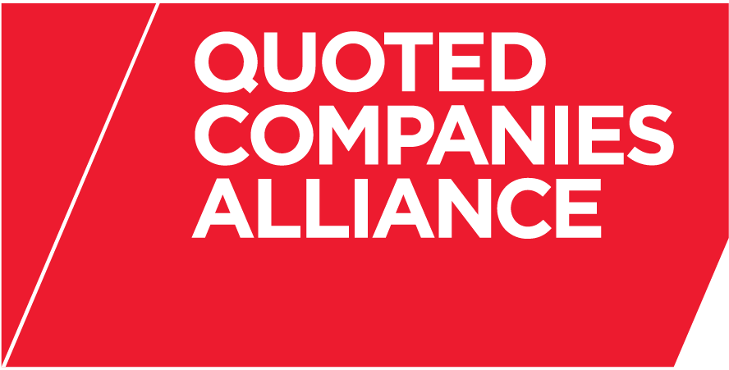

THE QUOTED COMPANIES ALLIANCE
SHARE SCHEMES EXPERT GROUP
PROPOSED MEETING DATES FOR 2014

Time: 5.30pm (unless otherwise advised)

Thursday 6 February 2014 (Venue: TBA)

Thursday 15 May 2014 (Venue: TBA)

Thursday 4 September 2014 (Venue: TBA)

Thursday 4 December 2014 (Venue: TBA)

